**Data preparation**

Missing values

Missing values in ts1: 1113924

Missing values in ts2: 378953

Max missing range in ts1: 3579

Max missing range in ts2: 2139

Max missing range in ts1: 4.97 days

Max missing range in ts2: 2.97 days

Monday 258

Tuesday 259

Wednesday 261

Thursday 260

Friday 253

Sunday 243

Name: datetime, dtype: int64

Monday 261

Tuesday 262

Wednesday 261

Thursday 261

Friday 260

Sunday 259

Name: datetime, dtype: int64

Without Saturday

Missing values in ts1: 926004

Missing values in ts2: 191033

Max missing range in ts1: 2859

Max missing range in ts2: 1419

Max missing range in ts1: 3.97 days

Max missing range in ts2: 1.97 days

Non-uniform distribution: Instead of a single peak around the expected 2-minute interval, the histogram shows a wide distrution of time gaps

The frequency of streak lengths decreases as the streak length increases. This indicates that shorter streaks (smaller time gaps) are more common in the data, while longer streaks (larger time gaps) are less frequent.

Presence of outliers: The histogram show some bars far away from the main distribution, representing unusually large time gaps. These outliers could be due to holidays, market closed days, or other events that cause irregular time gaps in the data.

Skewness: The histogram might to the right , indicating that the time gaps are not symmetrically distributed around the expected 2-minute interval. This could suggest that there are more frequent occurrences of either shorter or longer time gaps than expected.

Long tails: The histogram has a long tail, indicating that there are a significant number of time gaps that are much larger than the expected 2-minute interval. This could be a sign of irregularities in the data collection process or other factors affecting the time intervals between data points.

Distribution of time gaps:

count 104817.000000

mean 17.668966

std 101.135273

min 2.000000

25% 2.000000

50% 4.000000

75% 12.000000

max 5718.000000

Name: ts1, dtype: float64

count 2271.000000

mean 168.236900

std 453.508762

min 2.000000

25% 2.000000

50% 2.000000

75% 4.000000

max 2838.000000

Name: ts2, dtype: float64

Time Series 1 (ts1):

There are 104,817 time gaps in the data.

The average time gap is approximately 17.67 minutes.

The standard deviation of the time gaps is around 101.14 minutes, indicating a wide range of time gaps.

The minimum time gap is 2 minutes.

The 25th percentile (Q1) is 2 minutes, meaning 25% of the time gaps are 2 minutes or less.

The median (50th percentile) is 4 minutes, indicating that half of the time gaps are 4 minutes or less.

The 75th percentile (Q3) is 12 minutes, meaning 75% of the time gaps are 12 minutes or less.

The maximum time gap is 5,718 minutes, which is quite large compared to the other percentiles.

Time Series 2 (ts2):

There are 2,271 time gaps in the data.

The average time gap is approximately 168.24 minutes.

The standard deviation of the time gaps is around 453.51 minutes, indicating a wide range of time gaps.

The minimum time gap is 2 minutes.

The 25th percentile (Q1) is 2 minutes, meaning 25% of the time gaps are 2 minutes or less.

The median (50th percentile) is 2 minutes, indicating that half of the time gaps are 2 minutes or less.

The 75th percentile (Q3) is 4 minutes, meaning 75% of the time gaps are 4 minutes or less.

The maximum time gap is 2,838 minutes, which is quite large compared to the other percentiles.

From these statistics, we can observe that Time Series 1 has a higher average time gap and a larger maximum time gap compared to Time Series 2. However, both time series have a wide range of time gaps, as indicated by their large standard deviations.

**Data exploration**

**

**Seasonality**

Use imputed values for seaosnility

43849

Resampled data for frequency: H

Correlation between Price and Trend: 0.9998978566448516

1828

Resampled data for frequency: D

Correlation between Price and Trend: 0.9994058250798947

262

Resampled data for frequency: W

Correlation between Price and Trend: 0.9171791041373469

61

Resampled data for frequency: M

Correlation between Price and Trend: 0.9237217246022549

43849

Resampled data for frequency: H

Correlation between Price and Trend: 0.9997904486884698

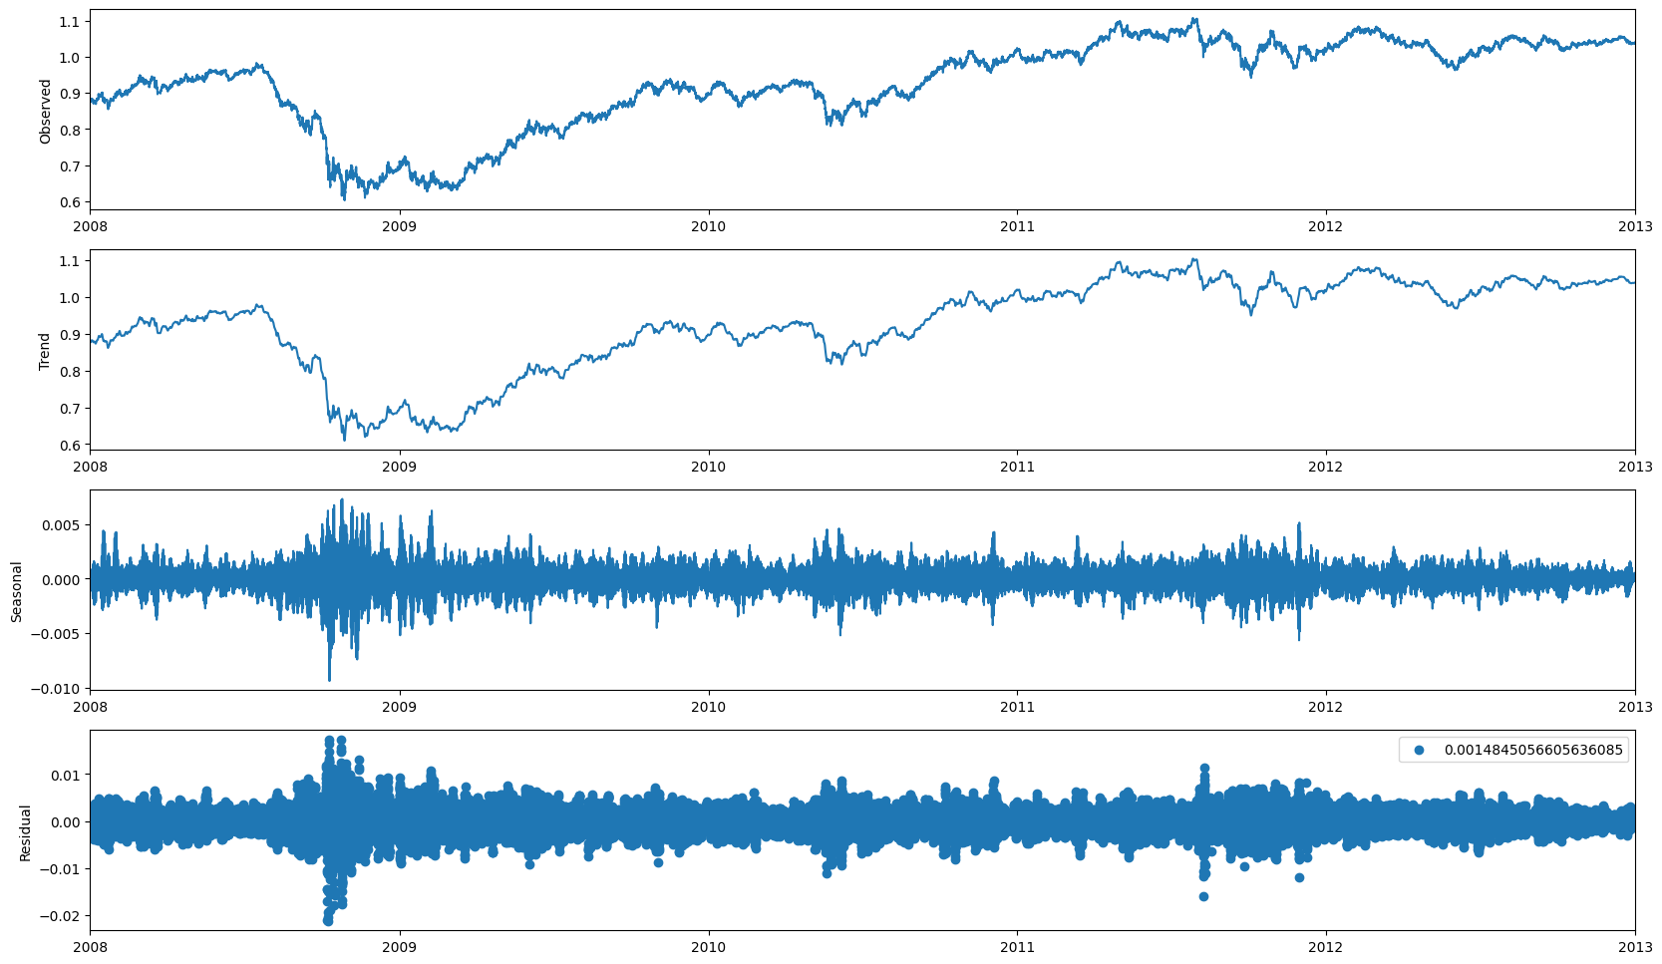

1828

Resampled data for frequency: D

Correlation between Price and Trend: 0.9990555753629836

262

Resampled data for frequency: W

Correlation between Price and Trend: 0.9134282349765372

61

Resampled data for frequency: M

Correlation between Price and Trend: 0.9251240931794542

**Trend**

**Cyclitic**

**Statistical analysis**

**Outliers/noise**

My personal journey in the world of cryptocurrency began around 2016 when I first heard about Bitcoin and its underlying technology, blockchain. Intrigued by the concept of decentralization and its potential to disrupt traditional financial systems, I decided to dive deep into the subject. I started by reading the original Bitcoin whitepaper by Satoshi Nakamoto and subsequently explored various resources to learn more about blockchain technology, smart contracts, and decentralized applications.

.

In order to gain a hands-on understanding of the technology, I invested in several cryptocurrencies such as Bitcoin, Ethereum, and a few altcoins. This allowed me to familiarize myself with various wallets and exchanges, including both centralized exchanges (CEXs) like Coinbase and Binance, and decentralized exchanges (DEXs) like Uniswap and Sushiswap.

During this time, I also began using MetaMask, a popular Ethereum-based wallet, which has been instrumental in helping me interact with various decentralized applications (dApps) and participate in decentralized finance (DeFi) platforms. Through my experience with DeFi, I've been able to engage in yield farming, liquidity provision, and other innovative financial strategies that are unique to the blockchain ecosystem.

My personal cryptocurrency journey began in 2016 when I first learned about Bitcoin and its underlying technology, blockchain. I decided to delve deep into the subject because I was intrigued by the concept of decentralisation and its potential to disrupt traditional financial systems. I began by reading Satoshi Nakamoto's original Bitcoin whitepaper and then explored various resources to learn more about blockchain technology, smart contracts, and decentralised applications.

I purchased several cryptocurrencies, including Bitcoin, Ethereum, and a few altcoins, to gain a hands-on understanding of the technology. This allowed me to become acquainted with a variety of wallets and exchanges, including centralised exchanges (CEXs) such as Coinbase and Binance, as well as decentralised exchanges (DEXs) such as Uniswap and Sushiswap.

During this time, I also started using MetaMask, a popular Ethereum-based wallet that has been helpful in interacting with various decentralised applications (dApps) and participating in decentralised finance (DeFi) platforms. I've been able to engage in yield farming, liquidity provision, and other innovative financial strategies that are unique to the blockchain ecosystem.

My strong background in computer science, mathematics, and data analysis, combined with hands-on experience in cryptocurrency investing, trading, and DeFi, has prepared me to excel in a crypto quant fund. I am enthusiastic about blockchain innovation and skilled at developing and implementing quantitative strategies, so I am confident in my ability to contribute effectively to your team.

1. Strong work ethic: I am committed to delivering high-quality work and meeting or exceeding deadlines on a consistent basis. My commitment and focus have been critical to the success of previous projects.
2. Analytical mindset: I have a natural aptitude for problem solving and data analysis, which allows me to spot trends, patterns, and opportunities that others may miss.
3. Team player: I am an effective communicator and collaborator, allowing me to collaborate effectively with colleagues and contribute to a positive, productive team environment.
4. My employers have praised my ability to take the initiative and drive projects forwards with minimal supervision, while also being open to feedback and guidance when needed.